**Aidan Brown**

**GEOG 501 Fall 2023**

# Deliverable 1

One screen capture for each of the three study areas, showing the 2001 orthophoto in the background and the digitized coastlines for 2001 and 1995 with clearly visible and distinguishable symbology with a label or legend to show which line is from which year (so that’s 3 screen captures in total):

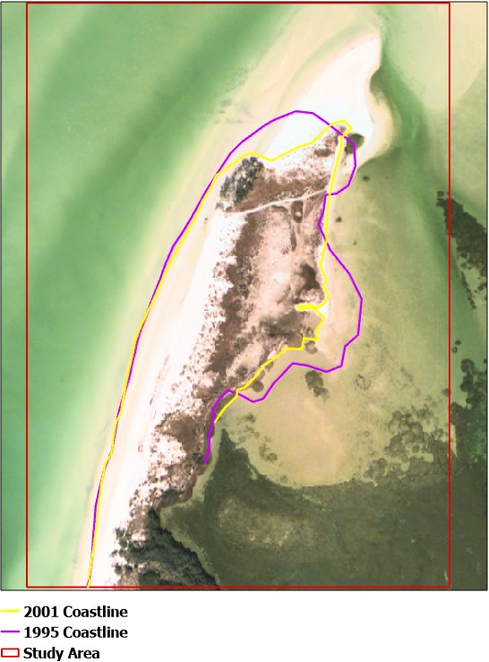

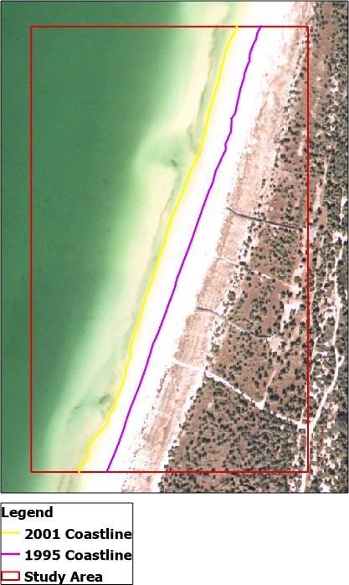

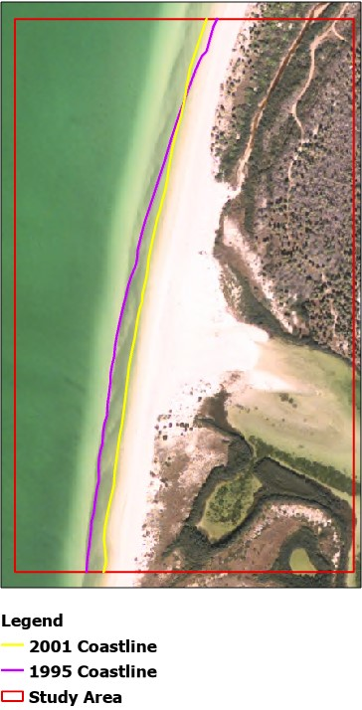

|  |  |  |
| --- | --- | --- |
| **Transect ID** | **Coastline Shift from 1995 to 2001 (feet) - indicate loss or gain** | **Approximate Northing (feet)** |
| 1 | -164 ft | 1,350,878.75N ft |
| 2 | -69 ft | 1,350,151.95N ft |
| 3 | -5 ft | 1,349,312.74N ft |
| 4 | -34 ft | 1,348,122.36N ft |

# Deliverable 2

Table like the one below, including all transects:

# Deliverable 3

generally the entire coastline has reduced in size. The only outliers were measurements taken at high tide, which may have skewed measurements slightly. One very notable physical feature that clearly illustrates erosion of the coastline is the peninsula on the north of the island. From the photos taken in 1995 a coastline is visible and can be clearly outlined, but comparing to the photos in 2001 it's very hard to distinguish between sand and the coastline.

|  |  |  |
| --- | --- | --- |
| **Transect ID** | **Coastline Shift from 1995 to 2001 (feet) - indicate loss or gain** | **Approximate Northing (feet)** |
| 5 | +69 ft | 1,346,955.87N ft |
| 6 | +106 ft | 1,345,754.37N ft |
| 7 | +82 ft | 1,344,786.35N ft |
| 8 | +29 ft | 1,343,768.57N ft |
| 9 | -28 ft | 1,342,767.17N ft |
| 10 | +16 ft | 1,341,614.31N ft |
| 11 | -65 ft | 1,340,607.02N ft |
| 12 | -91 ft | 1,339,225.65N ft |

# Deliverable 4

What is the area of the island that disappeared between 1995 and 2001 (in acres):

The area of the island is **14 acres**.

# Deliverable 5

Screen capture of the newly created polygon:

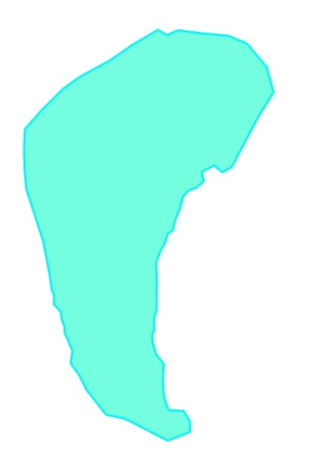

# Deliverable 6

Submit your file geodatabase, which contains all your digitizing, as a ZIP file. with your assignment in addition to your regular lab report.